PCCCS Orphanage Management System……

**Kamala Education Society’s**

**Pratibha College of Commerce & Computer Studies, Chinchwad, Pune-19 **

A

Project Report

On

**“Orphanage Management System”**

**Developed by,**

4867: Mr. Sohan Chavan

4848: Mr. Prashant Ghadge

SYBBA (CA)

Under

Savitribai Phule Pune University

May 2021

PCCCS Orphanage management system

**Kamala Education Society’s**

**Pratibha College of Commerce & Computer Studies, Chinchwad, Pune-19**



**Certificate**

This is to certify that **“ Mr. Sohan Chavan ” and “Mr. Prashant Ghadge”** has**/** have satisfactorily completed thetitled **“Orphanage Management System”** for **S.Y .BCA** under the **Savitribai Phule Pune University** in the academic year **2020-2021.**

**_______________________________________ ____________________ Pro. Sarika Jadhav Prof. Hemalata Chavan Dr. BabaSaheb Sangale Project Guide Head of Department Principal**

**__________________ _________________ Internal Examiner External Examiner**

**Date:**

PCCCS Orphanage Management System

**ACKNOWLEDGEMENT**

Any efforts to produce successful creation require the help Guidance and support of many people and their experience. We would like to express our sincere and heartfelt gratitude to all of them.

We would like to take this opportunity to thanks all the people who have directly or indirectly helped this project. We would like to thank our guide Prof. Sarika Jadhav for her valuable guidance.

**Mr. Sohan Chavan ,Mr. Prashant Ghadge**

PCCCS Orphanage Management System

**Index**

|  |  |  |
| --- | --- | --- |
| **Sr. No.** | **Content** | **Page No.** |
| **1** | Introduction | **1-5** |
| **2** | Problem Definition | **6-7** |
| **3** | Need for System | **8-10** |
| **4** | Scope of Proposed System | **11-12** |
| **5** | Feasibility Study & Fact Finding Technique | **12-14** |
| **6** | Hardware and Software Requirement | **15-16** |
| **7**  **7.1**  **7.2** | Design Specification            Flow chart diagram  Data Flow Diagram  ER Diagram | **16-19** |
| **8** | Data Dictionary | **20-22** |
| **9** | Sample Input & Output Screen | **23-29** |
| **10** | Testing Strategy | **30-31** |
| **11** | Limitations | **32-33** |
| **12** | Future Enhancement | **33-34** |
| **13** | Conclusion | **34-35** |
| **14** | Bibliography | **35-36** |

PCCCS Orphanage Management system

1.**Introduction**

**What is orphanage?**

An Orphanage is the Home like facility for the children who have lost their parents and no one is ready to take their responsibility.

As soon as we hear the word “Orphan”, our stomach sinks at the thought of knowing how the ill-fated children grow up without parents or relatives, totally in a strange environment where in no one is there to shield them against the harshness of society.

The Idea of starting an orphanage is very noble, but if you want to do a business out of it, it is an ugly business. An organized Orphanage works as an NGO – Non Government Non-profit organization.

As a human when you read an article about orphans, heart aches and generally we get the urge of doing something. Many of us think about it and forget in a while, few goes to the extent of donating some money but very few really put the effort to go beyond and start an orphanage.

PCCCS Orphanage Management System

2. **Problem Definition**

**Today, Orphanage doner and adopt facing the problem as mentioned below.**

* Orphanages get limited aid from the government and are seeking financial help to meet educational expenses of children. Many have not taken in new children in four months as they struggle to cope.
* BATTLING THE VIRUS Child care homes being run by non-governmental organisations (NGOs) in the region are facing a fund crunch due to a dip in donations during the Covid-19 pandemic.
* The orphanages get limited aid from the government and are seeking financial help to meet educational expenses of children. Many have not taken in new children in four months as they struggle to cope.
* The Supreme Court has also sought details from the Centre on funds for children homes. The government will file an affidavit in two weeks about funds made available to states and Union Territories to run child care institutions.

PCCCS Orphanage management system

**Adoption in India is a challenge, the pandemic made It a night mare.**

* For months, the lockdown prevented adoptive parents from getting to their babies. Now, they are facing hurdles in the legal process.
* Although adoptive mothers may face many of the same child rearing issues as biological mothers, forming a family through adoption is different (Smith and Howard, 1999).
* Adoptive mothers of special needs children often ﬁnd that the

adoption alters the balance of the family system and results in stress and dis-equilibrium, sometimes to the extent that the adoption is disrupted (where the child is returned to foster care).

* Rosenthal (1993) evaluated previous studies on the disruption rate for older special needs adoptions and found disruptions

to range between 10 and 15 percent.

* Research shows that less than 1 percent of infant adoptions disrupt (National Adoption Information Clearing house ,n.d.), d these infant adoptive parents are signiﬁcantly less.
* Thus, this research will focus on special needs adoptions where potential stressors are more prevalente monstrating that the issues facing.

PCCCS Orphanage management system

**3. Need for System**

* To maintain the data with the minimum storage spa The number of orphans and vulnerable children in need of public support is not known precisely. UNAIDS, UNICEF and USAID have jointly prepared estimates of the number of orphans by country and type for 2003 to 2010 (UNAIDS *et al*. 2004). However, not all of these children need public support. Some may be living well with their surviving parent while others may be living with relatives who can afford to support them. Our definition of orphans in need includes only those living in households with incomes below the national poverty line (World Bank 2002). Of course, many children who are not orphaned are also in immediate need of assistance. The identification of children in need of assistance can best be done through community assessments. Many countries have adopted their own definitions of orphans that differ in important ways

PCCCS Orphanage management system

from the standard definition used by UNICEF and other international organizations.

* After limiting the target population to orphans living under the poverty line, for the purposes of this analysis we use three further definitions of need as proxies for these community assessments. They are *double orphans* (children under the age of 18 who have lost both parents), *double and near orphans* (‘near orphans’ refers to children with a chronically ill parent who will become orphans in the next year), and *double orphans and near orphans plus one-half of maternal and paternal orphans*. These definitions refer to all orphans not just those children orphaned because of AIDS. (These estimates are based on current levels of anti-retroviral treatment (ART). If the number of people treated expands very rapidly in the next few years, fewer parents will die and the number of orphans would be about 5% less.) Near orphans are especially vulnerable since

PCCCS Orphanage management system

they may receive inadequate care if they have a chronically ill parent and they will shortly become new orphans, requiring significant adjustments in their living arrangements. Community workers can identify families with chronically ill adults. In our projections we estimate this number as the children who will become single orphans the following year.

PCCCS Orphanage management system

**4. Proposed Method**

There are some objectives that have to be achieved through the system.

The objectives are

**Secure System :** Data stored in the home care's center database must be protected from being access by unauthorized users

**Faster Data Processing And Accessing :** To be fast in data processing and accessing by using query and index are required.

**Data Integrity :** Data integrity required through for the appropriate use of primary and foreign key rule. The primary key will help to avoid data inconsistency and redundancy.

**Backup And Recovery :** Data backup and recovery create a safety values, allowing the database administrator to ensure the availability of consistent data.

PCCCS Orphanage Management System

**5. Feasibility Study & Fact Finding Technique**

All projects are feasible unlimited resources and definite time. It is most product and necessary to evaluate the feasibility of the project at the earliest possible time. Months or years of efforts, thousand of rupees and untold professional embarrassment can be averted if an ill-conceived project is recognized early in the definition phase. Feasibility of producing qualify software is reduced if the risks involved in producing are high. During software engineering there are different aspects of the feasibility study. Feasibility study means to determine where the current system is feasible in the following aspects.

**Operational Feasibility:**

Operational Feasibility is dependent upon determining human resources to the project. It refers to projecting whether the system will operate and be used once it is installed. The project has been developed in such a way that it becomes very easy even for a person with little computer knowledge to operate it.

PCCCS Orphanage management system

This software is very user friendly and does not require any technical person to operate. Thus the project is even operationally feasible.

**Technical Feasibility:**

·In this feasibility, the system engineer evaluates the availability of technical resources to achieve performance.

The technical feasibility in the proposed system deals with the technology used in the system. It deals with the hardware and software used in the system whether they are of latest technology or not.

**Economic Feasibility**

·Economic or financial feasibility will vary depending on the characteristics of the system to be developed, the relative size of the project and the expected return.

The system developed and installed will be good benefit to the organization.

PCCCS Orphanage management system

**Fact Finding Techniques:**

**Record Review:**

In this type of techniques, as we have to display to study the existing or previous records and reports that help us in generation an overview for our system which is to be design

**Interview:**

Analyst use interviews to collect information from individuals who they consider should be the sources who are current users, etc. the analyst should be a face conversation with users and administrator of the system set of questions is prepare.

**Questionnaire:**

This another types or fact finding techniques. It allow analyst to collect information from a group of individual who may or may not be using the system thus resulting some times in irrelevant data and data redundancy.

PCCCS Orphanage management system

**6. HARDWARE / SOFTWARE REQUIREMENT**

**Language(s) to be used:**

* HTML & CSS
* Java script

**Hardware Requirements:**

* RAM: 1 GB or more
* Hard Disc: 200MB or more
* Processor: Intel core processor
* Processor Speed: 2.3 GHz

**Software Requirements:**

* HTML & CSS
* Java script
* Frame work : Netbeans
* Operating system : Windows 10
* Browser: Google Chrome, Mozilla Firefox, Internet explorer’s

PCCCS Orphanage management system

**7.Design specification**

D

Connect with

Contact us form

User

If forget password

Forget password

ER dig. 7.1 (Admin control)

PCCCS Orphanage management system

admin

Hospital

connect with

connect with

Resource center

ER dig. 7.2 (Home Page)

PCCCS Orphanage management system

**7.3 System Model: DFD**

Database

Admin

Account

Donation management

Contact management

Orphanage management system

Contact page

Donation form

Resource

Dfd dig. 0th Level DFD

PCCCS Orphanage management system

donate

D

Orphan India

user

have

manage

Has a

account

admin

update

**ER Diagram (Home Page)**

Resource center

Dfd dig. (1st Level DFD )

PCCCS Orphanage Management System

**8. Data Dictionary**

Dataset :

Table name : user

Primary Key: id

|  |  |  |  |
| --- | --- | --- | --- |
| Field name | Data type | Contraints | Data description |
| name | varchar (40) | not null | it is show the user name |
| id | varchar (20) | primary key | it is show the user id |
| mobile no. | varchar (20) | not null | it is show the user mobile no |
| address | varchar (50) | not null | it is show the user address |
| b .o. d | varchar (40) | not null | it is show the user b.o.d |
| email | varchar (20) | not null | it is show the donation email |
| password | varchar (40) | not null | it is show the user password |

PCCCS Orphanage management system

Dataset:

Table name: admin

Description: Contains the data type contact us

Primary key : id

|  |  |  |  |
| --- | --- | --- | --- |
| Field name | Data type | Contraints | Data description |
| name | varchar (20) | not null | it is show the name |
| id | int (20) | primary key | it is show the id |
| age | varchar (40) | not null | it is show the age |
| email | varchar (40) | not null | it is show the email |
| phone no | varchar (20) | not null | it is show the phone no |
| b.o.d | varchar (20) | not null | it is show the b.o.d |
| city | varchar (40) | not null | it is show the city |

Dataset:

Table name: user

Description: contains the user’s data who buy system

Primary key: id

PCCCS Orphanage management system

|  |  |  |  |
| --- | --- | --- | --- |
| Field name | Data type | Contraints | Data description |
| fname | varchar (40) | not null | first name of user |
| lname | varchar (40) | not null | last name of user |
| email | varchar (40) | not null | email of user |
| donation | varchar (40) | not null | donation of orphan |
| contact | varchar (40) | not null | contact of user |
| password | varchar (40) | not null | password of contact us form |
| account | varchar (40) | not null | account of user |

**User interfaces**

The graphical user interface (GUI) is the platform that will allow the inputs  from the user ends a kind of interaction with the system. GUIs are used in mobiles,  media players, games and many others. We can design visual composition and the  temporal behaviour of the GUI in any of the software application as well as  programming in the areas of the human computer interaction.

The GUI for this  project will be widely based on the training and the testing phase which in turn  will allow the capture and train of the image. The minimum requirements for the software would be python along with  OpenCV and the required dataset

The minimum requirements for the hardware  would be intel i3 or any processor above it and 4 core CPU. Operating systems of  windows 10 will be sufficient and random-access memory 8GB required.  From the user end a computer or laptop active internet connection and a scanner  optional.

Tkinter is a simple GUI module used for implementing fairly simple GUI  and helps us to interact with code in a simple way. Though for understanding the  code it’s not important for you to know how it works.

PCCCS Orphanage management system

**9.Sample Input & Output Screen**

Home page :

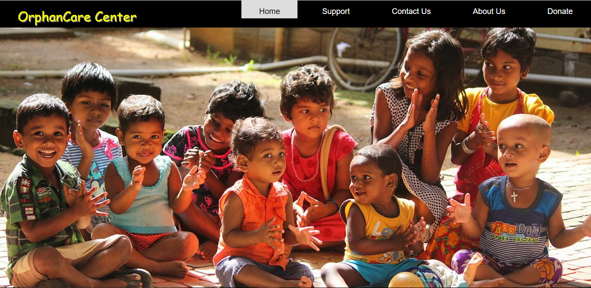

Fig.1 starting the application home page.

**Orphanage management system**

PCCCS Orphanage Management System

Contact us Form

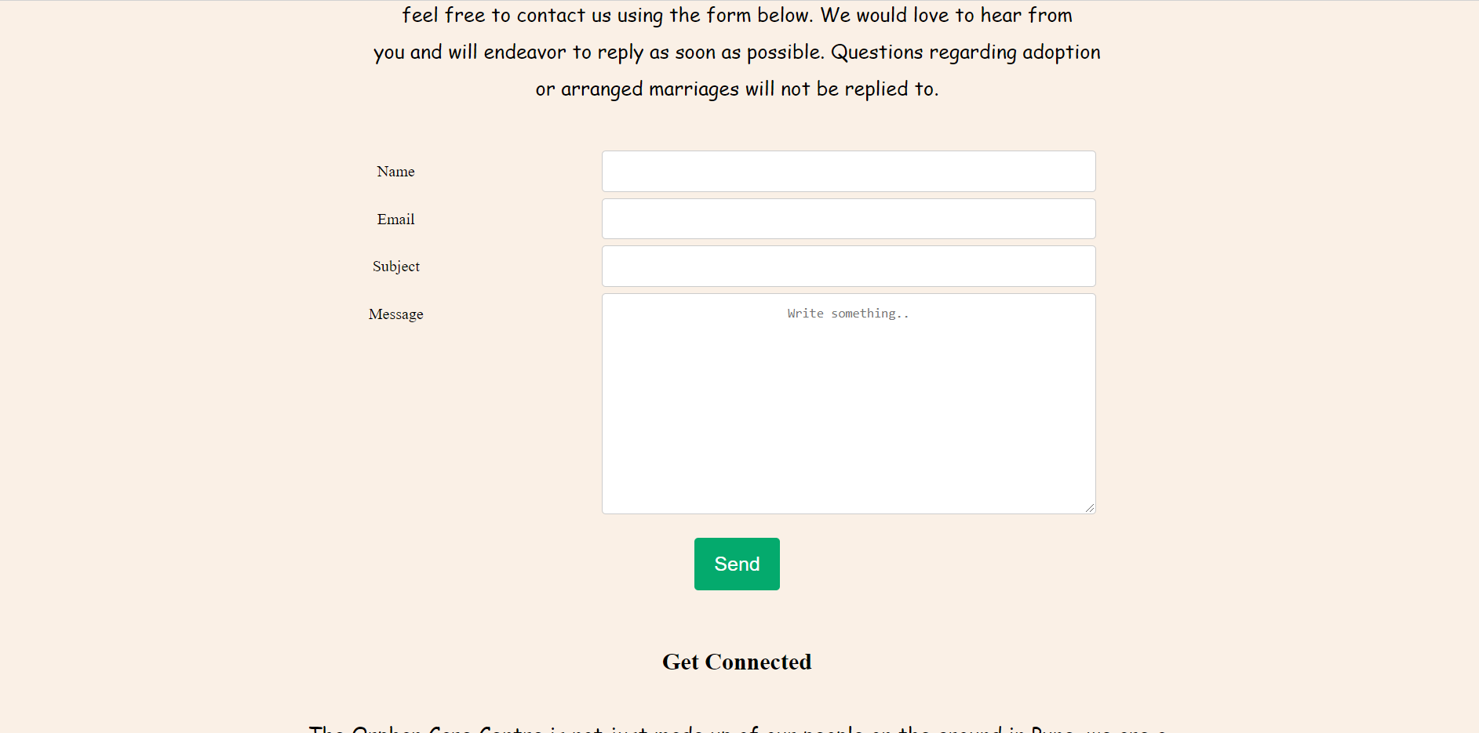

Fig.2.1 This is the contact us form page where admin should be contact their self.

PCCCS Orphanage Management System

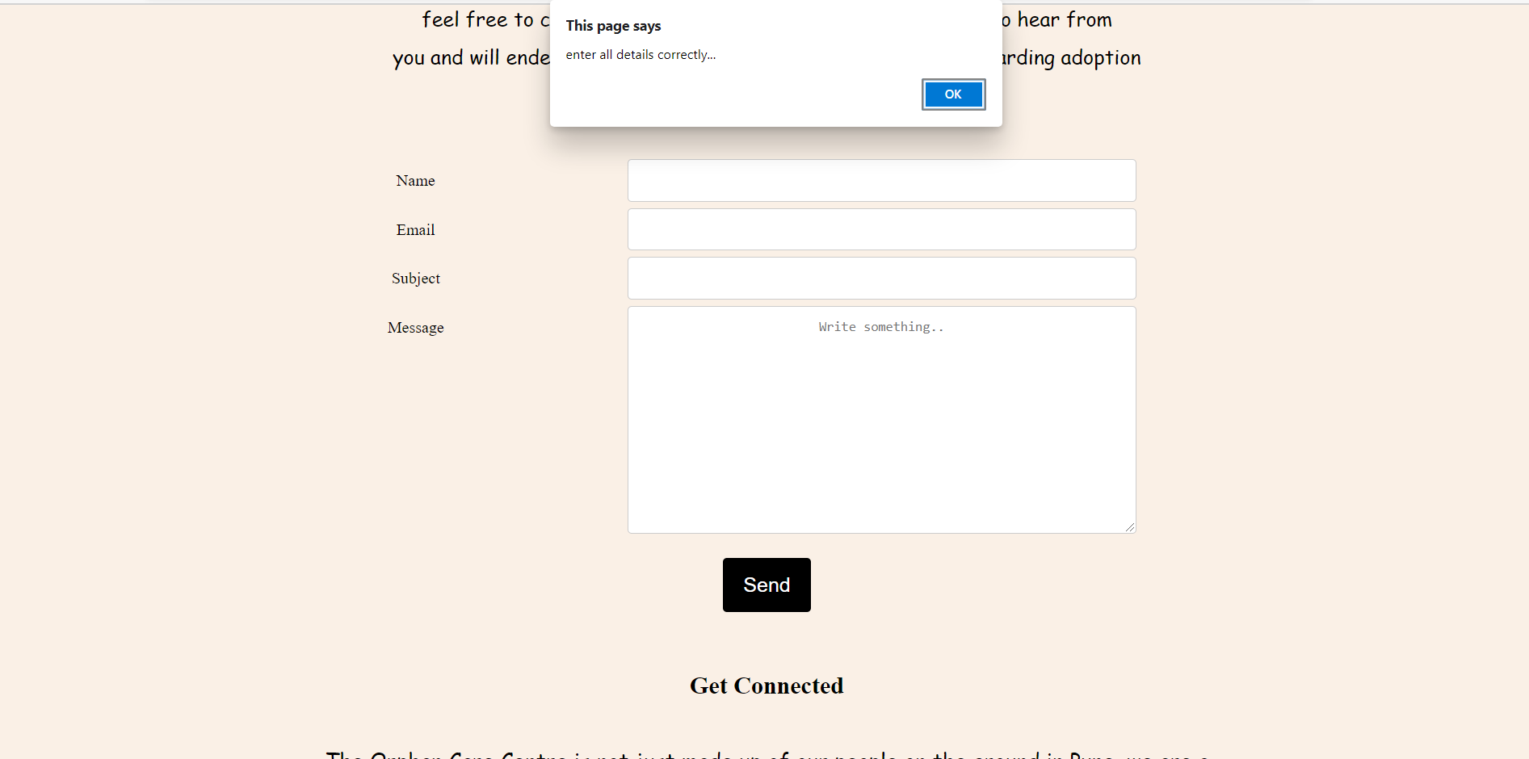

Fig.2.2 If it is wrong data filed the form where errors.

Pcccs Orphanage management system

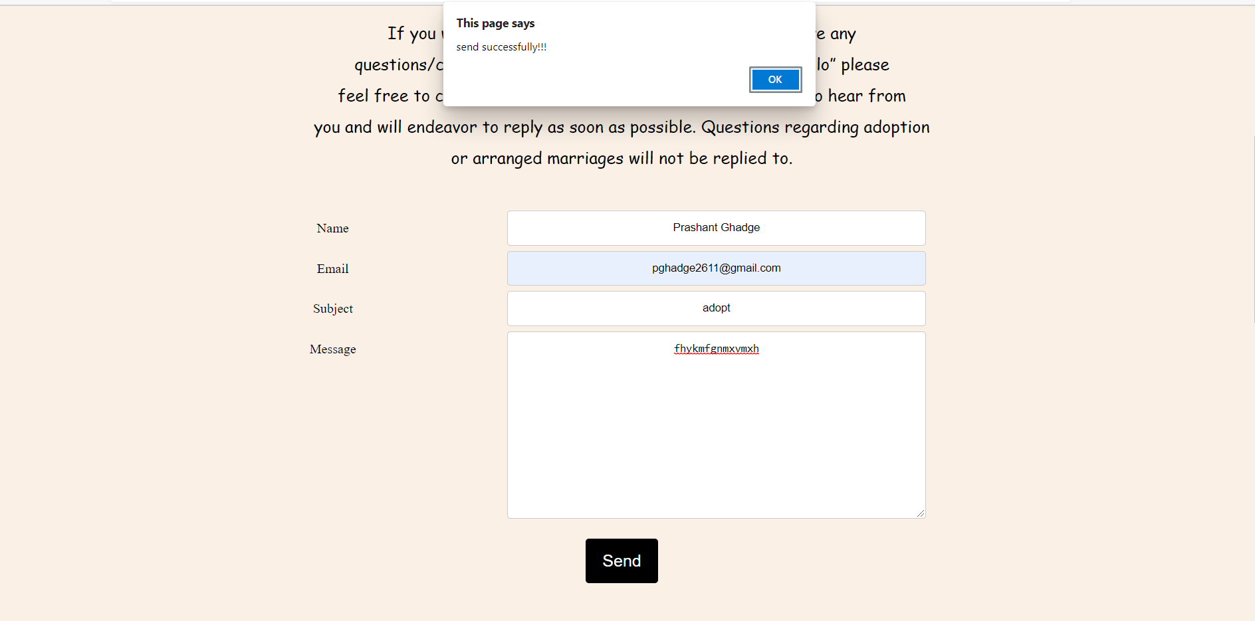

Fig.2.3 If it is succesfully submitted the contact us form.

PCCCS Orphanage management system

Donation form:

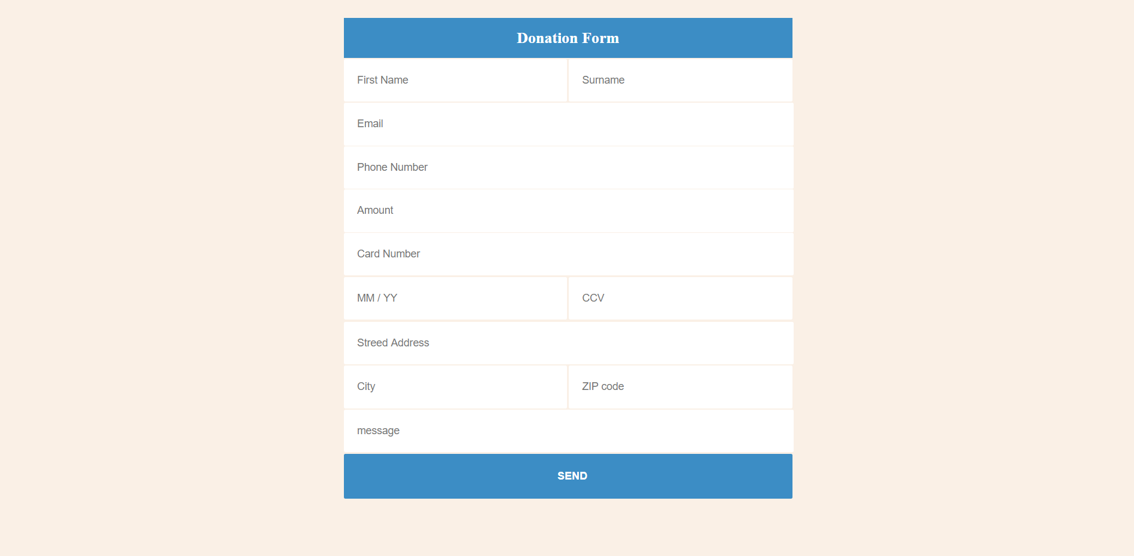

Fig.3 This is the donation form page where admin should be donate their self.

PCCCS Orphanage Management System

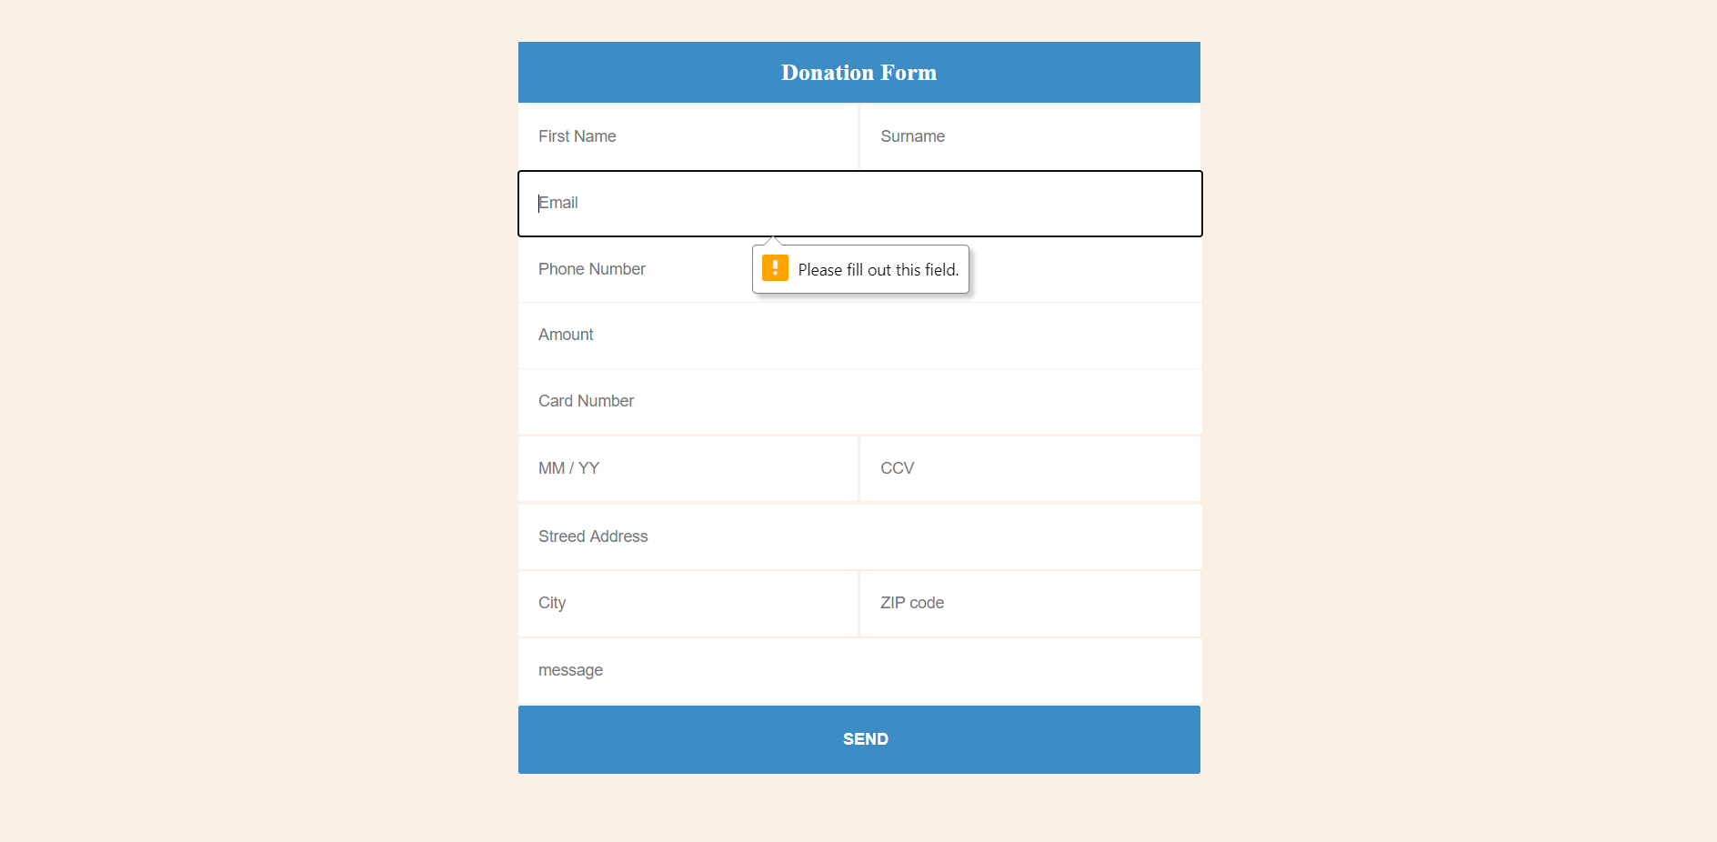

PCCCS Orphanage Management System

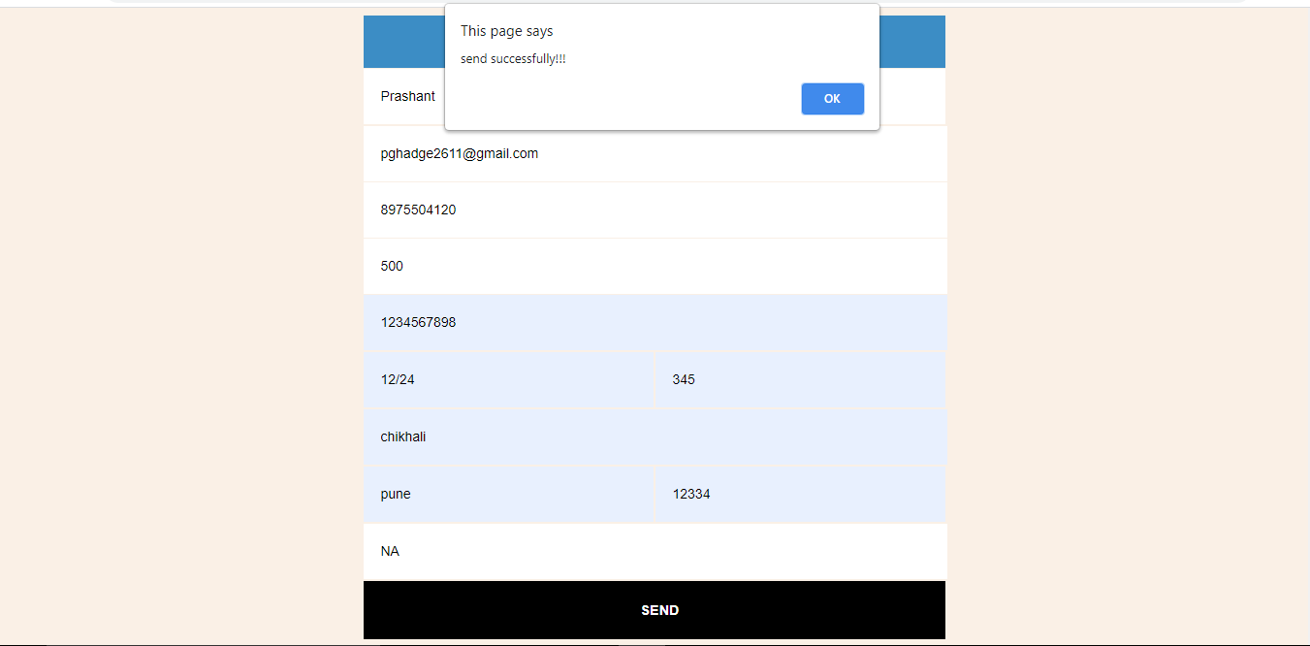

Fig 3.3 This is the donation form where the form is successfull submitted.

PCCCS Orphanage Management System

**10.Testing Strategy**

Software testing is a critical element of software quality assurance and represents the ultimate review of specification, design and coding. In fact, testing is the one step in the software engineering process that could be viewed as destructive rather than constructive.

A strategy for software testing integrates software test case design methods into a well planned series of steps that result in the successful construction of software. Testing is the set of activities that can be planned in advance and conducted systematically. The underlying motivation of program testing is to affirm software quality with methods that can economically and effectively apply to both strategic to both large and small-scale systems.

**Unit Testing :**

In this testing each and every program is tested individually using record to whether that program produced satisfactory outputs and validation also. Unit testing focuses verification effort on the smallest unit of software design, the module. The unit testing we have is white box oriented and some modules the steps are conducted in parallel.

**Integration Testing :**

Integration testing takes input modules that have been unit tested. group them in aggregates ,appliers tested in an integration test plan to those aggregates top-down testing is an approach to integrated testing where the top integrated modules are tested step until the end of related module.

PCCCS Orphanage management system

**Validation Testing :**

Validation testing is important to check whether the various data controls present on the page are accepting the desired data and giving the expected output.

**System Testing :**

System testing is software and hardware testing. System testing takes as its input all of the integrated software component the have pass integration testing and also software testing.

PCCCS Orphanage Management System

**11.Limitations**

* The Limitation of Orphanages and Lack of Parental Care
* [The Risk of Harm to Young Children in Institutional Care](http://www.crin.org/docs/The_Risk_of_Harm.pdf)
* [Research on Institutional Care of Vulnerable Children](http://www.crin.org/docs/US%20Instititional%20Care%20Research%20Studies%20NACAC.pdf) .
* [Children in Residential Care: The Zimbabwean Experience](http://www.crin.org/docs/BCN%20-%20Children%20in%20Residential%20Care%20-%20Zimbabwe.pdf)
* [A Last Resort: The Growing Concern About Children in Residential Care](http://www.crin.org/docs/A%20last%20resort.pdf) International Save the Children Alliance, London, UK.
* [Institutions vs. Foster Homes: The Empirical Base for a Century of Action](http://www.crin.org/docs/Barth.pdf) Richard P. Barth, Jordan Institute for Families, University of North Carolina.
* [No Place Like Home: A Research Study of the Operations, Management, and Care Offered by Residential Facilities for Orphaned and Vulnerable Children](http://www.crin.org/docs/noplacelikehome.pdf)

* [Home Truths: The Phenomenon of Residential Care for Children in a Time of AIDS](http://www.crin.org/docs/Residential%20Care%20report%20Final%202007-06.pdf) Helen Meintjes, Sue Moses, Lizette Berry, and Ruth Mampane,

PCCCS Orphanage Management System

**12. Future Enhancement**

* It can be summarizing that the future scope of the project circles around maintaining information regarding :

* We can add advance software for venue management system including more facilities.
* We can host the platform on online servers to make it accessible worldwide.
* Integrate multiple load balancers to distribute the loads of the system.
* Create the master and slave database structure to reduce the overload of the database queries.
* Implementing the backup mechanism for taking backup on codebase and database on regular basis on different servers.
* The above mentioned points are the enhancements which can be done to increase applicability and usage of the project. Here we can maintain the records of venue and booking. Also it can be seen that now a days the players are versatile, i.e. so there is a scope for introducing a method to maintain the venue management system. Enhancement can be done to maintain all the venue, event, booking, customer, and enquiry.

PCCCS Orphanage Management System

**13. CONCLUSION**

Orphanage is the  name  to describe a  residential  institution  dedicated  to  the care of orphans whose parents are deceased. Parent or any legal guardian responsible for supporting the child or children, but in the absence of these guardian to take responsibility for the children, they lose all the care and attention to fit into their surroundings. This paper and proposed design (system) of an orphanage home management information system that will eliminate the conventional manual (Paper) management to a digitized (computerized) management system. The study so far has looked at vast importance of computer Information System (IS) and how they  are applied to  the information  and management in  the orphanages information.

PCCCS Orphanage management system

**14. Bibliography**

* The following books & Websites are referred for project study

1. https://indianorphanage.com/

2. <http://www.learncpp.com/>

3. <http://www.w3schools.in/cplusplus/intro/>